Eckovation

Python Programming Internship Report

Natural Language Identification

Made By:

Shakti Taneja

Acknowledgements

This is to acknowledge that without the support and help of Mr. Govind Das and all other members of Eckovation it would have been a very difficult time for me to learn so much in such little time.

**Abstract**

This project works on the principles of Natural Language Processing, it combines the principles of computer science and artificial intelligence in a way that helps us with operations such as identification, translation etc. that we can perform on documents, sites, files and other things.

The basic aim of this project is to understand and be able to apply the python language effectively. And also understand what Natural Language Processing is about and what its scope is.

**Table of content**

|  |  |  |
| --- | --- | --- |
| **Serial Number** | **Title** | **Page no.** |
| 1. | Introduction | 1 |
| 2. | Code | 2 |
| 3. | Working of the program | 3 |
| 4. | Coding difficulty | 4 |
| 5. | Future Research | 5 |
| 6. | Result | 6 |

**Introduction**

The Language Identification program works on the principles of Natural Language Processing or NLP which is an area where computer science and artificial intelligence are concerned. The program asks for a sentence in some language from the user, identifies the language used and shows the input along with the name of the language as output. For this program we will be using Python language to code, also Python has a handy library for language identification “nltk” ready to download which eases the difficulty of coding the program.

**Code**

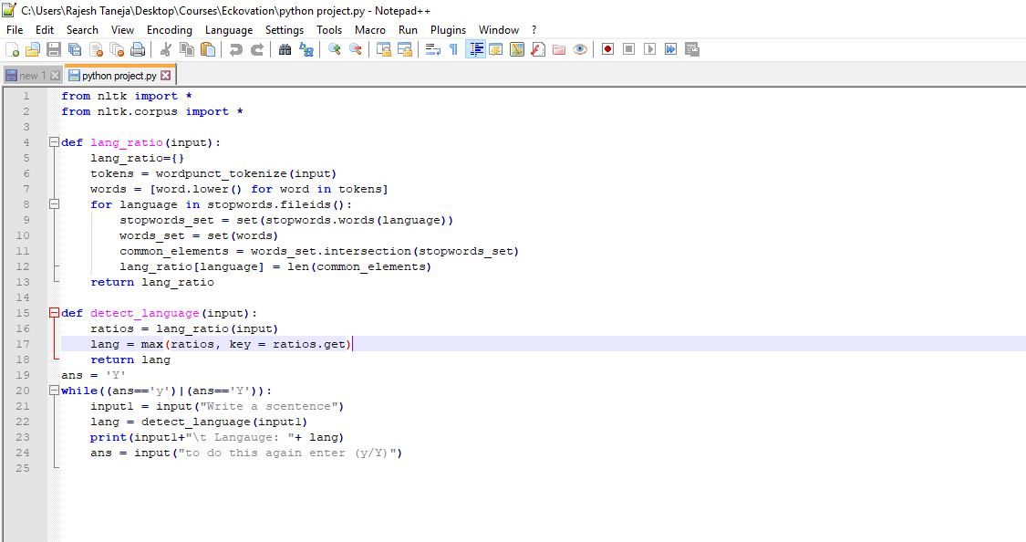

**Working of the program**

The program asks for input in the form of a sentence or a word from user through input command which is then checked by the nltk library to check which language the input is closest to and prints that language as the output.

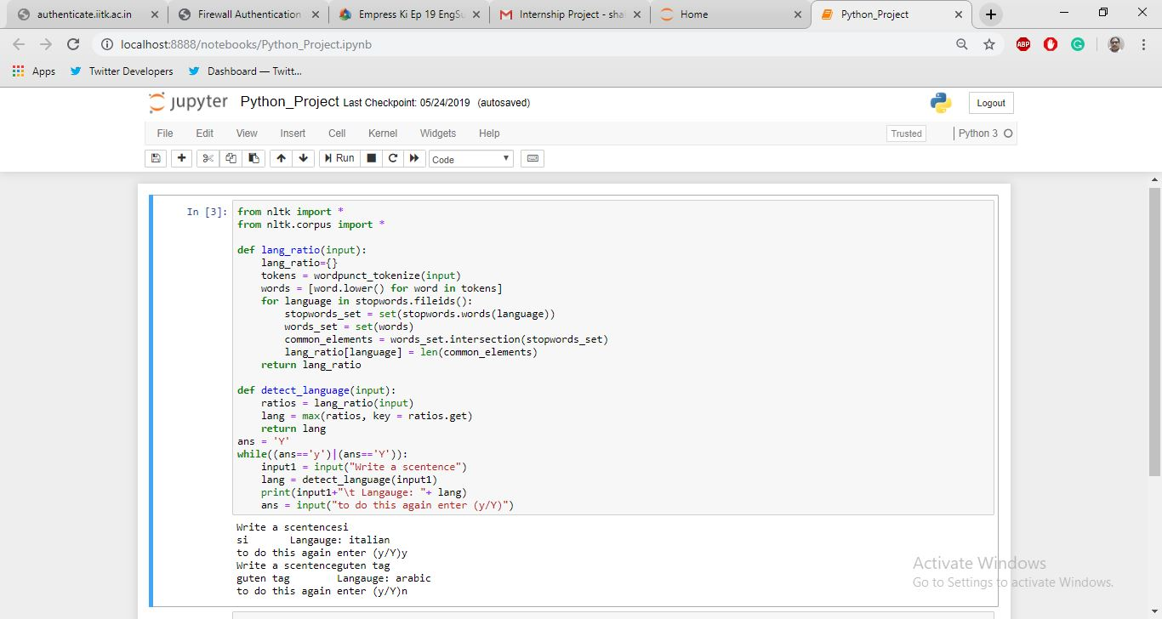

**Coding Difficulty**

To make sure that the program is executed successfully it is necessary that the following requirements are met:

1. There are no problems with syntax
2. The required libraries are included
3. The logic of the program is correct

Although the code itself is not too long nor is it very difficult still it is very much possible that program may not work from system to system, this happens because the files required are at different locations in some systems which results in an error.

**Future Research**

There can be more options for input such as taking a document or vocal file to check for language usage. Translation to understand the input in some other language is also another area where work can be done.

**Result**

The program works almost perfectly considering what it is designed to do. We have also learnt the Python language and the basic principles behind Natural Language Processing while working on the project. As a result I consider this project to be a success completing the aims for this project.